Exhibitor’s Registration and Information Packet

Southeast Regional User Group (SeRUG) 2019 Annual Conference
April 9 – 12, 2019

TRADEWINDS ISLAND RESORTS
5600 GULF BOULEVARD
ST. PETE BEACH, FL 33706
(727) 363-2215 - FAX (727) 363-2221

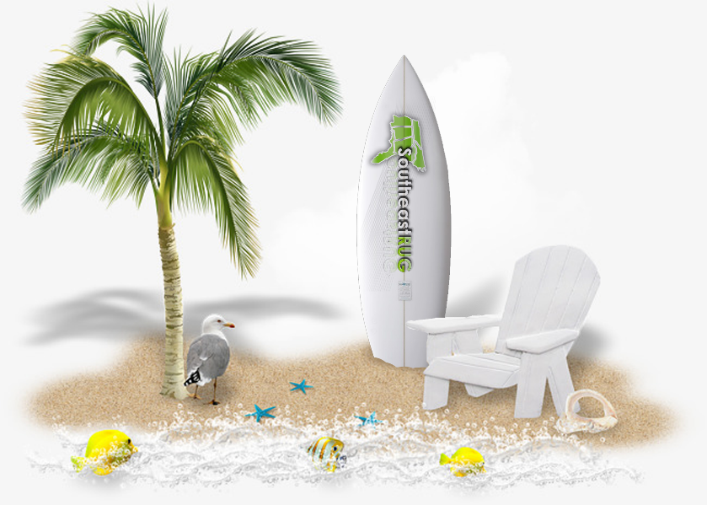

SeRUG 2019 will help promote your organization in several ways
- Your company logo and/or name will be highly visible on conference digital and printed material; Note: To assure inclusion of company information on conference printed material, requested information must be received by deadline March 15, 2019
- Comprehensive exhibitor sponsorship booklet provided to all attendees
- Exhibitor fees contribute to door prize giveaways for attendees, additional door prizes for your booth are welcome.
- Exhibitor materials can be included in the attendee bags in addition to your display booth.

Pricing and Sponsorships

Sponsorship Levels

Level | Price | # Tables | # Attendees | #Speaker Slot | Printed Ad Size
Platinum | $5,000 | 1 | 4 | 1 (1 hr. speaker session) | Full Page
Gold | $3,500 | 1 | 3 | n/a | 1/2 Page
Sliver | $2,000 | 1 | 2 | n/a | 1/4 Page

Note: Speaker sessions will be scheduled as part of the conference agenda.

Optional Opportunities

“Rip Curl Challenge” – $50
This is an "optional" opportunity for exhibitor participation and is in addition to the regular fees.
Benefit of exhibitor participation:
- Participating exhibitors will be Rip Curl sponsors for the conference
- Attendees will visit the exhibitor booth to receive a unique stamp.
- Only completed Rip Curl cards will be eligible for a Grand Prize.
- All “Rip Curl” fees will be used for the Grand Prize drawings.

Exhibitors Showcase - $25
This is an "optional" opportunity for exhibitor participation and is in addition to the regular fees.
Benefit of exhibitor participation:
- Company Name/Logo will be displayed at the media center.
- Company Name/Logo/Booth Information will be posted on the conference website.

Additional Bash Guest - $90 per person
Entry to the Bash is included for each person that is registered as an exhibitor attendee either through the main sponsorship or through the purchase of an additional exhibitor attendee. If additional Bash Guest tickets are needed (e.g. for spouse or guest not registered as an Exhibitor attendee), they can be purchased along with your sponsorship.

Sponsorship Benefits
This year the welcome reception will be held indoors in the exhibitor hall. This will allow additional time for exhibitor/attendee networking.

All booth packages include:
- Electricity and internet access
- Mega networking opportunities
- Complimentary food during the opening reception and daily events
- Drink tickets
- Booth Dimensions: 8 ft. wide x 6 ft. deep
- Table Size 60”x 30”

Cancellation Policy
All SeRUG cancellations and refund requests must be sent in writing via e-mail or regular mail. Telephone requests will not be honored. If necessary to cancel by USPS, please allow sufficient time for a delivery to be received by applicable deadline date.

USPS Mailing address:
Southeast Regional User Group
2655 Ulmerton Rd, STE 101
Clearwater, FL 33762

Email address: southeastrug@gmail.com

- A full refund will be provided for cancellation requests received at least 30 days prior to the start of the conference, minus a $25 processing fee.
- A 50% refund of registration costs plus a $25 processing fee will be provided for cancellations received between 29 to 14 days before the start date of the conference
- No refund will be issued for cancellation requests received less than 14 days before the first day of the annual conference.
- All requests must include the following information.
  - Requestor Name (first and last)
  - Requestor email address
  - Address (where refund check should be sent)
  - Date when conference registration was submitted
  - Conference registration Confirmation Number
  - Name of proxy person (if registered by someone other than requestor)
  - Name of person or organization refund check should be made out to

NOTE: All information is required. Omitting information may result in a rejection of your request. If you have any questions regarding refund, please contact us at: southeastrug@gmail.com

Registration Instructions

Complete the online registration at https://cernerusers.workoutloud.com/Event/exhibitor-only-cerner-southeast-regional-user-group-serug-2019-annual-conference

Review the online exhibitor floor plan to determine booth availability and include your choice when registering.

Please be sure to include the following information when you register.
- Sponsorship level
- Booth preference (1st, 2nd and 3rd choice). Booth assignment will be made once payment is received.
- Representatives attending the conference need First Name, Last Name, Email, Title and Organization Name to register
- Any Optional Opportunities
  - Additional Bash Guests
  - Participation in “Rip Curl Challenge” event

Platinum Sponsors Only: Submit your Session Topic, Speaker, Email and Phone to Jeremy Black (Jeremy.black@palmettohealth.org) no later than February 1, 2019.

Organization Descriptions and Logos: Remember send your organization description and logo to Carrie Ross (Carrie.Ross@baycare.org) no later than March 15, 2019.

If you have questions please contact Carrie Ross (Carrie.Ross@baycare.org or 727-315-5281, Shirley Shipp (Shirley.Shipp@baycare.org or 727-467-4621, Katherine Cherry (Katherine.Cherry@baycare.org), Nicole Mello (Nicole.Mello@bayare.org or 727-467-4778), Jessica Johnston (Jessica.Johnston@msj.org or 828-213-0187) or Sandy French (sfrench@shrinenet.org).

Hotel Reservations
TRADEWINDS ISLAND RESORTS
5600 GULF BOULEVARD
ST. PETE BEACH, FL 33706
(727) 363-2215 - FAX (727) 363-2221

https://www.tradewindsresort.com/serug

Room Rate: $225/night (The rate applies to hotel stays arriving on or after April 8, checking out by April 12, 2019)
Deadline: Reserve your room by March 18, 2019 to receive the conference rate!

Exhibitor Materials for Attendee Bags

Exhibitors have the option to include their promotional materials in the attendee bags. If you would like to include your company’s promotional items, please review the information below. This is only for items to be included in the conference bags and not for items to be given away at your booth. If you need to ship materials for your booth, please follow the instructions on the last page of this document.

- Include a quantity of 200
- All items must be received by April 4, 2019
- Items should be sent to:
BayCare Health System
Information Services
Attention: Shirley Shipp
2995 Drew Street
Clearwater, FL 33759

Setup times and daily activities (high level)

Tuesday April 9, 2019
  - Exhibitor registration: 9am – 4pm
  - All exhibitors will need to have their booths set up prior to 4pm
  - Hotel check-in time is 4:00 PM
  - Welcome reception: 5:00 PM – 7:00 PM and includes both exhibitors and attendees. Hors d’oeuvres and drinks will be served.

Wednesday April 10, 2019
    - Exhibit area will be open at the following times:
• 7:00 am - 8:30 am
• 10:00 am - 10:30 am
• 11:30 am - 1:30 pm
• 2:30 pm - 3:30 pm
• 4:30 pm - 6:00 pm
    - Exhibitors are invited to Keynote Presentations.
    - Continental Breakfast is served for exhibitors and attendees 7:00 am—8:30 am.
    - Morning and Afternoon snacks are served for exhibitors and attendees.
    - Lunch is included and is served 11:30 am - 1:30 pm.

Thursday April 11, 2019
    - Exhibit area will be open at the following times:
• 7:00 am - 8:30 am
• 10:00 am - 10:30 am
• 11:30 am - 1:30 pm
• 2:30 pm - 3:30 pm
• 4:30 pm - 6:00 pm
    - Exhibitors are invited to Keynote Presentations.
    - Continental Breakfast is served for exhibitors and attendees 7:00 am — 8:30 am.
    - Morning and Afternoon snacks are served for exhibitors and attendees.
    - Lunch is included and is served 11:30 am - 1:30 pm.
    - Evening social event (BASH) 6:30 pm – 9:30 pm
    - Evening social event (BASH) includes dinner and entertainment for both exhibitors and attendees.

Friday April 12, 2019
    - Exhibit area will be open at the following times:
• 7:30 am - 9:00 am
• 10:00 am - 10:30 am
    - Exhibitors are invited to Keynote Presentations.
    - Continental Breakfast is served for exhibitors and attendees 7:30 am — 9:00 am
    - Lunch will not be served
    - Morning break (10:00 AM – 10:30 AM) attendees will have the opportunity to visit exhibitor booths.
    - Hotel Check-out is 11:00 AM
    - Exhibit hall must vacate by 1:00 PM

Shipping and Storage

Packages:
- Packages may be delivered to the Hotel no more than 7 days prior to the event.
- Packages or materials of excessive weight (more than 100 pounds) or value must be approved for receipt by the Hotel prior to shipping.
- All package handling fees are due and payable upon delivery.
- Please refer to the TradeWinds Packages and Freight Fees document for additional details.
- Shipping and receiving hours are 8:00am - 5:00pm Monday through Friday.
- Should special arrangements for delivery be necessary, please contact Rob Hyypio at 727-363-2259 or rhyypio@twresort.com.
- The following information must be on all packages to ensure proper delivery:

Hold For: Ms. Shirley Shipp / Southeast Regional User Group
Contact Phone: 727-455-1802
Group: Southeast Regional User Group 2019 Conference
Arrival: Tuesday, April 8, 2019
Shipping Address: TRADEWINDS ISLAND RESORTS
5600 GULF BOULEVARD
ST. PETE BEACH, FL 33706

Conference Services Manager: Rob Hyypio
Conference Services Manager Phone/Email: 727-363-2259 or rhyypio@twresort.com

Number of Boxes: (i.e. 1 of 2, 2 of 2, etc.)
- A storage fee per box per day will apply for any boxes received prior to 7 days of the first function. The TradeWinds Island Resort is not in any way liable for the contents of these packages.

